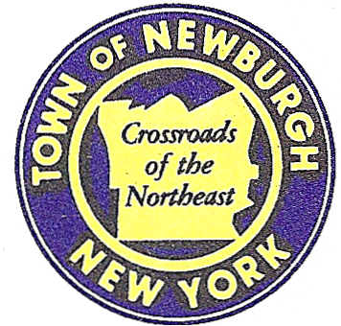

TOWN OF NEWBURGH
_______Crossroads of the Northeast __________________________
OLD TOWN HALL
308 GARDNERTOWN ROAD NEWBURGH, NEW YORK 12550

PLANNING BOARD
JOHN P. EWASUTYN, CHAIRMAN
TELEPHONE 845-564-7804
FAX 845-564-7802
E-MAIL: planningboard@townofnewburgh.org

PLANNING BOARD AGENDA

July 18th, 2019

*PLEASE NOTE: The Planning Board Meeting will start at 7:00 P.M. and all Applicants/Representatives
are to be present at that time. The Meeting will be held in the Meeting Room of Town Hall,
located at 1496 Route 300, Newburgh NY.*

- 182 South Plank Rd. (19-08) PUBLIC HEARING
182 South Plank Rd.
Section 64, Block 2, Lot 8.21
Zone: B.
Rep: Maser Consulting
555 Hudson Valley Ave. Suite 101
New Windsor, NY 12553

- The Polo Club (18-12) SENIOR HOUSING
Rt. 300 & Jeanne Dr. SITE PLAN
Section 39, Block 1, Lot 1 &2.12
Zone: R-3
Rep: Engineering & Surveying Properties
71 Clinton St.
Montgomery, NY 12549

- BJ’S Wholesale Club- Newburgh(19-07) SITE PLAN/SPECIAL USE
NYS Route 17K & Auto Park Place
Section 97, Block 2, Lot 44,46.2 & 45
Zone: IB
Rep: Maser Consulting, P.A.
555 Hudson Valley Ave. Suite 101
New Windsor, NY 12553

*WORK SESSION*
Project Readiness Discussion scheduled for 5:30 p.m. in the Meeting Room of
Town Hall on Thursday, July 18th, 2019

- 317 North Plank Road (18-23) SITE PLAN/ LOT LINE CHANGE
317 North Plank Rd.
Section 35, Block 3, Lot 6 & 7
Zone: B
Rep: Hudson Land Design
13 Chamber St
Newburgh, NY 12550

PLANNING BOARD BUSINESS
WORK SESSION

*WORK SESSION*
Project Readiness Discussion scheduled for 5:30 p.m. in the Meeting Room of
Town Hall on Thursday, July 18th, 2019.*

